**CSS (Margin, Padding, Border, box shadow)**

**Duration 4h (Totally 13)**

**Basic**

**1.Add padding for the pargraph from all side(Top, right, bottom, left):**

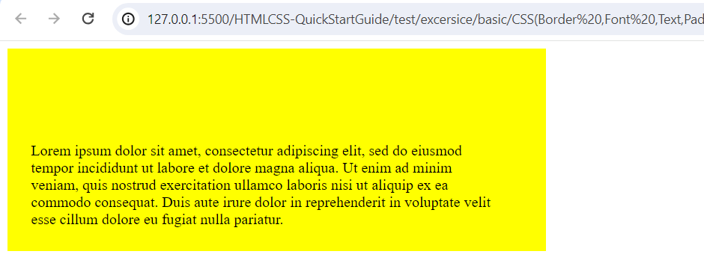

**2.Add border for the following:**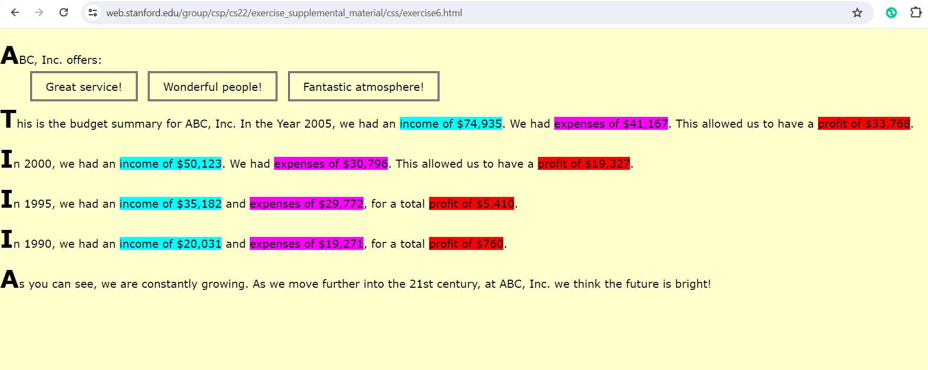

**3.Border:**

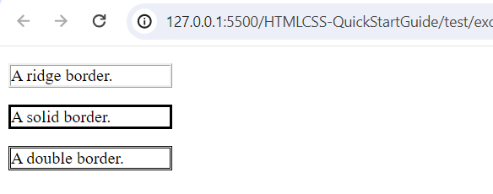

**4.Add box shadow:**

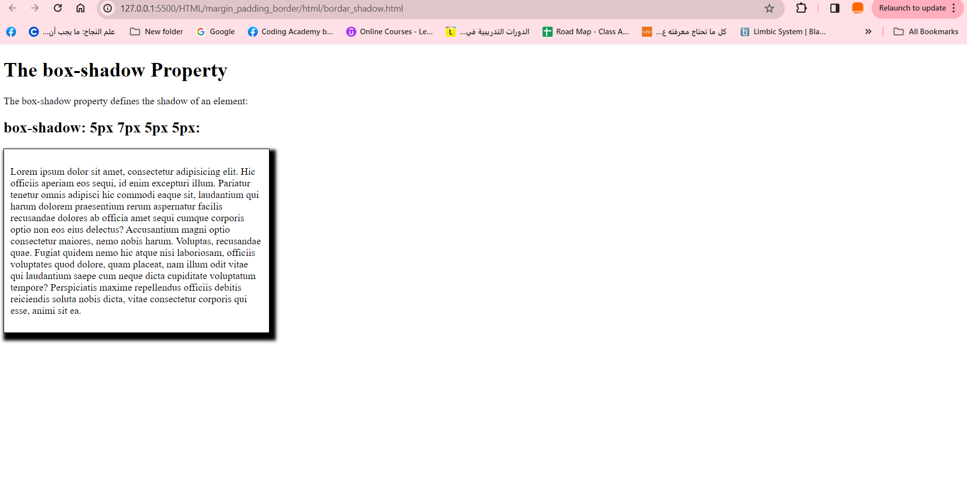

**Intermediate**

**5.Add padding and border:**

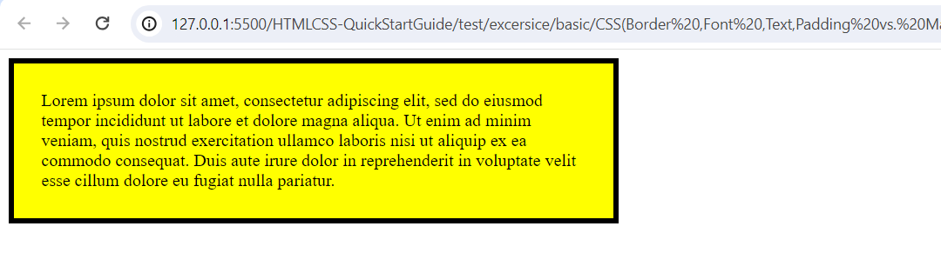

**6.Margin border, Padding:**

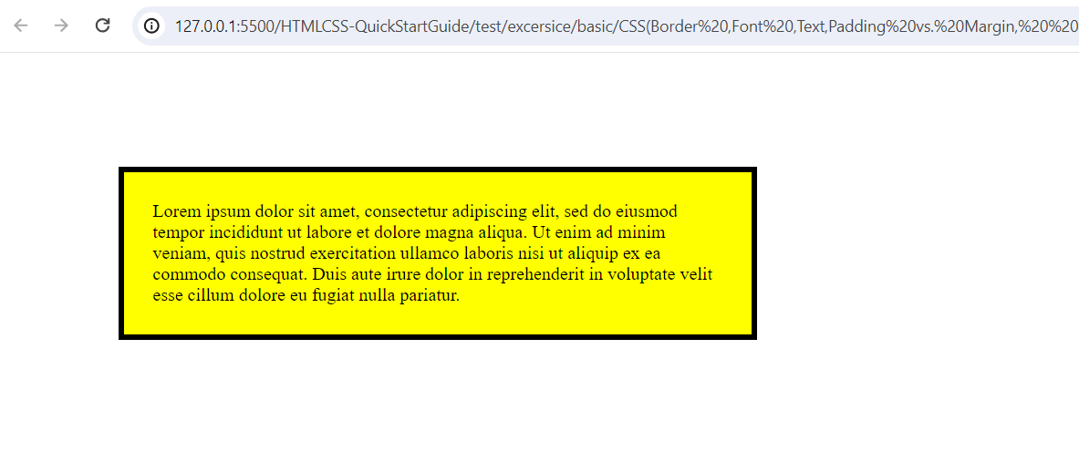

**7. Customise border:**

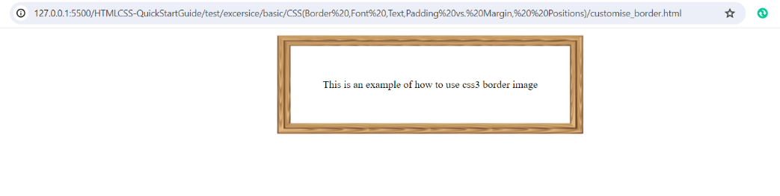

**8.Margin:**



**9. Center the div:**

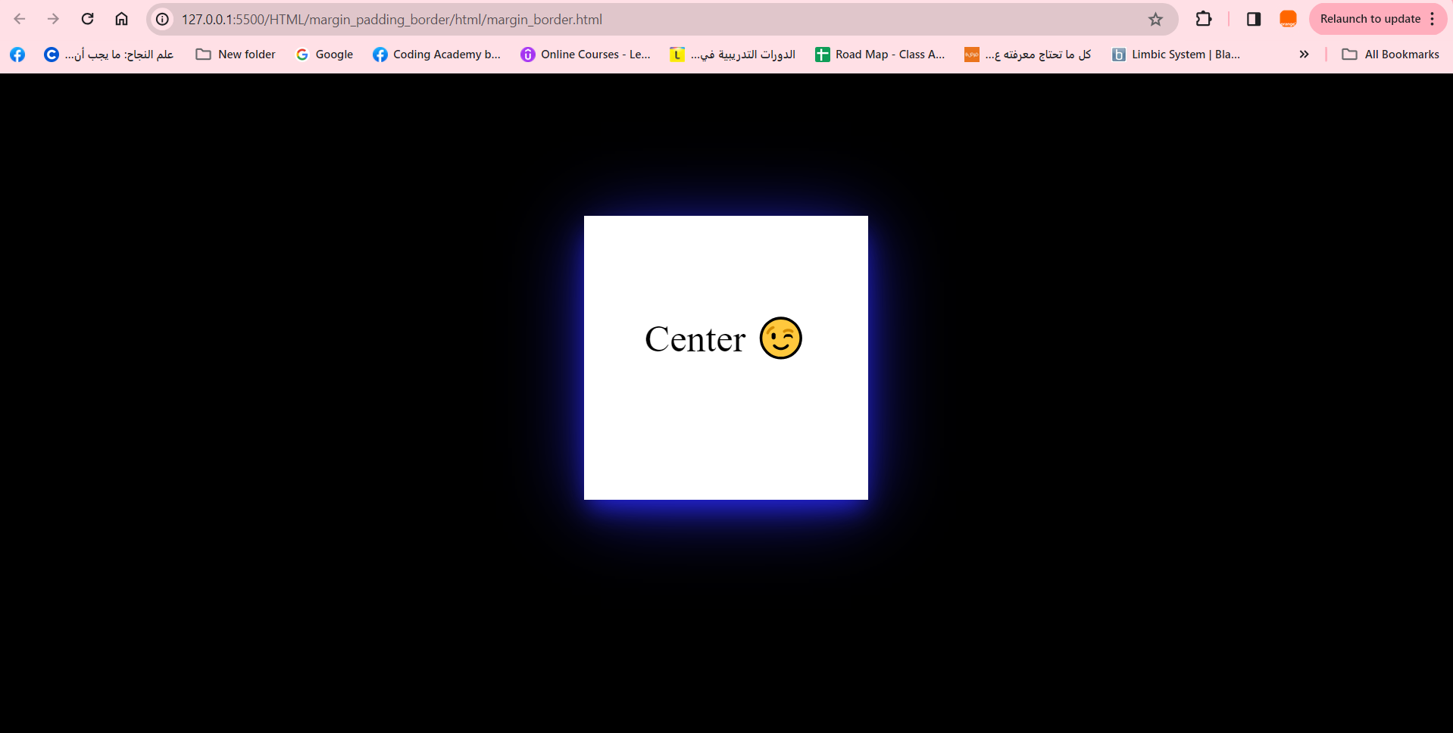

**Advanced**

**10.Multi Box Shadow:**

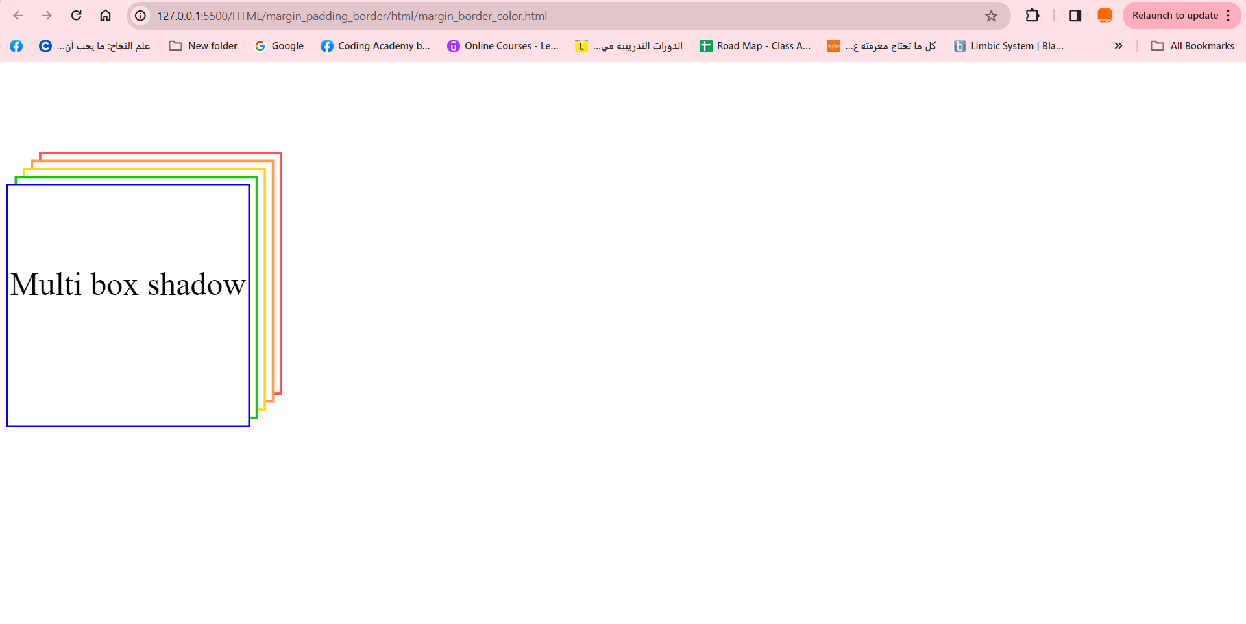

**11.Create web page contain 6 border each one have different style:**

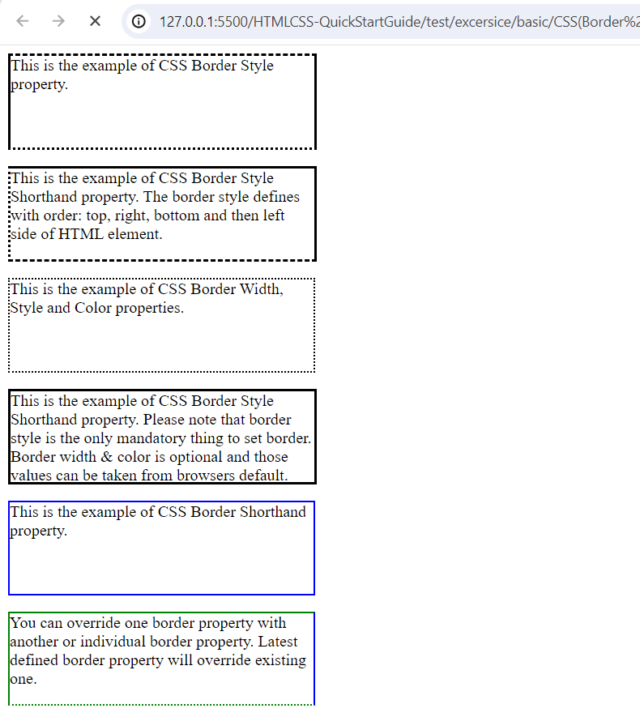

**12. add the previous we did last time add border and background color:**

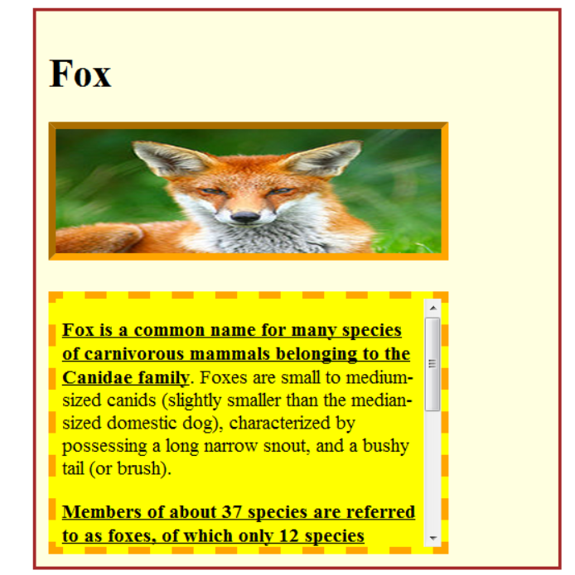

**13.Create the following website:**

